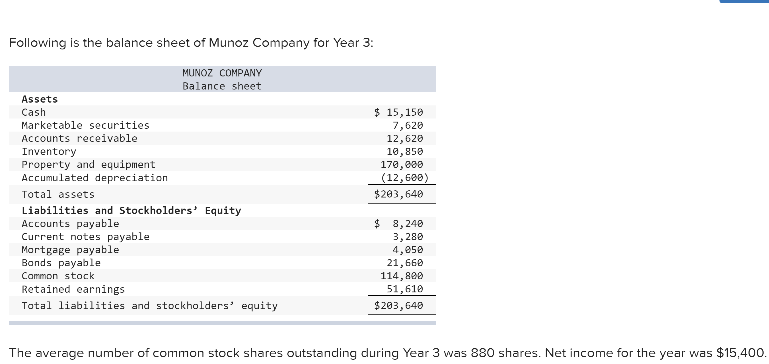
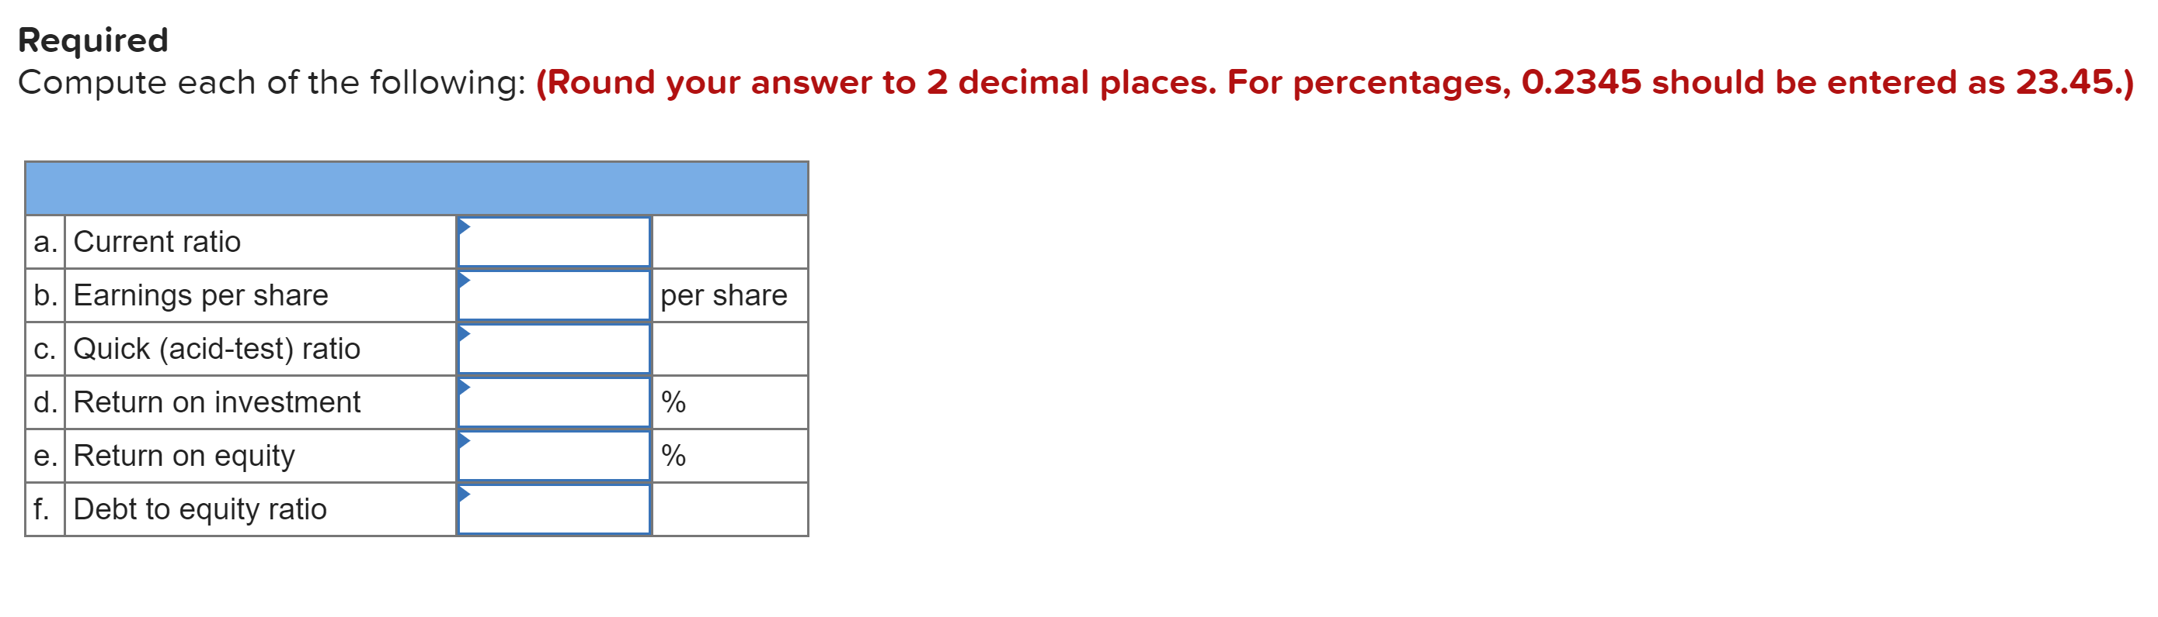
Solution
A).Current Ratio

Current ratio = Current Assets / Current Liabilities
Current Assets = $ 15150+$ 7620+$ 12620+$ 10850
=$46,240
Current Liabilities =$8240+$ 3280
=$11520
$ 46240/ $ 11520
Current Ratio = $ 4.01
B). Earnings per Share

EPS = Net Income - Preferred Dividend / No of Shares Outstanding
EPS = $15,400 / 880
EPS = $17.50
C).Quick Ratio

Quick Ratio = Quick Assets / Current Liabilitie
Quick Assets = $15,150 + $7620 + $12620 = $35390 ,
Current Liabilities= $11520
Therefore;
Quick Ratio = $35390 / $11520
= $3.07
D).Return on Investment

ROI = Net Operating Income / Average operating Assets
ROI = $15,400 / $203,640
0.07562x100
ROI = 7.56%
E).Return On Equity

ROE = Net Income / Shareholders Equity
Calculation of Return on equity (ROE):

ROE = Net income / Stockholders' funds
Stockholders' funds = Common stock + retained earnings
=114800+51600 = $166410
Now substitute the values in the above formula:
ROE = 15400 / 166410
0.0925x100
= 9.25%
F) .Debt to Equity:
Debt to equity = Debt / Equity
Debt includes all liabilities
Debt = Accounts payable + Current notes payable + Mortgage payable + Bonds payable
= 8240+3280+4050+21660
=$37230
Equity = $166410 (computed above)
Now substitute the values in the above formula:
Debt to equity ratio = $37230/166410
= 0.22
Therefore, debt to equity ratio is 0.22 times.

